ENTER TITLE HERE (16 pt TYPE SIZE, MAXIMUM OF 15 WORDS (IF POSSIBLE), UPPERCASE, BOLD)
Authors (14 pt Bold) Give the full name of all authors.
Received: ................, ......; Revised: ................, ......; Accepted: ................, ......
Abstract (12 pt Bold)
(10 pt Bold) Not exceeding 250 words. Clearly summarize the important findings of the paper. It should contain hard facts such as objectives, methods and major results. ……………………………………….………………………………….……………………………
…………………………………………………………………………………………..……………………………………………………………………………………………………..………………………………………………………………………………………………………..………………………………………………………………………………………………………..………………………………………………………………………………………………………..………………………………………………………………………………………………………..…………………………………………………………………………………………………………..………………………………………………………………………………………………………..………………………………………………………………………………………………………..………………………………………………………………………………………………………..………………………………………………………………………………………………………..………………………………………………………………………………………………………..………………………………………………………………………………………………………..……………………………………………………………………………………………

Keywords: (10 pt Bold) Provide 4-6 keywords which can be used as an index to direct readers to articles.
Introduction (12 pt Bold)
(10 pt) The introduction must provide the necessary background of the paper and a brief review of related literature. A clear statement of the objectives should also be included. ………………………………………….………
……………………………………………….……………………………………….…………………………………………………………….…………………………………….………………
………………………………….………………
…………………………………….……………
……………………………………………….…………………………………….…………………………………………………….…………………………………………………………….…………………………………….…………………………………………………….…………………………………………………………….…………………………………….…………………………………………………….…………………………………………………………….…………………………………….…………………………………………………….…………………………………………………………….…………………………………….…………………………………………………….…………………………………………………………….……………….…………………………………….…………………………………………………….……………………………………………….…………………………………………………….…………………………………………………………….…………………………………….………………….……………………………………………………………….…………………………………….…………………………………………………….………………………………………………….……………
¹ Give authors complete addresses. Contact information for the corresponding author, complete mailing address, and e-mail address. (Times New Roman 9 Italic)
² Give authors complete addresses. Contact information for the corresponding author, complete mailing address, and e-mail address. (Times New Roman 9 Italic)
* Corresponding author

Materials and Methods (12 pt Bold)
(10 pt) Describe the experimental procedures clearly enough for others to repeat the same experiment so that the same result could be obtained. ………………….……………………
………………………………….…………………………………………………….………………………………………………….……………………………………………….…………………………………………………….………………………………………………….……………………………………………….………………………………………………….…………………………………………………….………………………………………………….……………………………………………….………………………….………………………………………………….……………………………………………….…………………………………………………….………………………………………………….……………………………………………….…………………………………………………….…………………………….……………………………………………….…………………………………………………….………………………………………………….……………………………………………….…………………………………………………….……………………………………………….………………
Results and Discussion (12 pt Bold)
(10 pt) This section should contain “Results” and interpretation of the results in relation to existing knowledge. ………………….…………………
………………………………….…………………………………………………….………………………………………………….……………………………………………………….…………………………………………………….………………………………………………….……………………………………………….…………………………………………………….………………………….………………………………………………….……………………………………………….…………………………………………………….………………………………………………….……………………………………………….…………………………………………………….………………………………………………….……………………………………………….…………………………………………………….………………………………………………….……………………………………………….…………………………………………………….……………………………

Tables (10 pt Bold)
Number each table with Arabic numerals. Place a descriptive caption at the top of each. Footnotes should be identified by lower-case letters appearing as superscripts in the body of the table and preceding below the table. The same data should not appear in both tables and figures.

Table 1. …………………

T (K) | a (Å) | b (Å) | c (Å)
300 | 3.4005 | 3.4004 | 13.4005
350 | 3.4015 | 3.4014 | 13.4015
400 | 3.4025 | 3.4024 | 13.4025
450 | 3.4305 | 3.4304 | 13.4305

Figures (10 pt Bold)
(graphs, charts, line drawings, photographs) Figures with high-resolution images (300 dpi), preferably JPEGs. Type in the legend, with Arabic numbering, immediately below your image file.

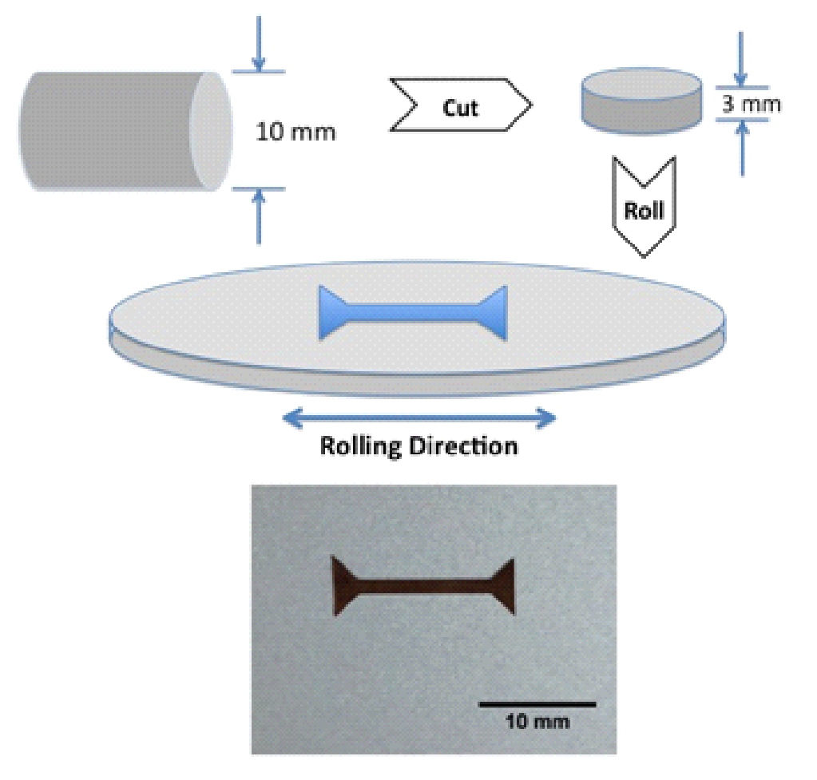Figure 1.…………………

Conclusions (12 pt Bold)
(10 pt) State conclusion (do not summarize) briefly. …………………..….…………………
………………………………….…………………………………………………….………………………………………………….……………………………………………….…………………………………………………….………………………………………………….……………………………………………….…………………………………………………….………………………………………………….……………………………………………….…………………………………………………….…………………………………………………………………….…………………………………………………….………………………………………………….……………………………………………….…………………………………………………….………………………………………………….……………………………………………….……………………………………….…………………………….……………
Acknowledgement (12 pt Bold)
(10 pt) List sources of financial or material support and the names of individuals whose contributions were significant but not deserving of authorship. …………..….…………………
………………………………….…………………………………………………….………………………………………………….……………………………………………….…………………………………………………….…………….…………………………….……………
References (12 pt Bold)
(8 pt) All references should be listed at the end of the paper using the following Suranaree Journal of Science and Technology patterns.
……………..………..….…………………………………………………….…………………………………………………….………………………………………………
…………………………….………………………………………………….……………………………………………….……………………………………………………
.………………………………………………….……………………………………………….…………………………………………………….…………………… ………
……………………….……………………………………………….…………………………………………………….…………………………………….………………
………………………………….……………………………………………….…………………………………………………….……………………………………………
…….……………………………………………….…………………………………………………….………………………………………………….………………………
………………………….…………………………………………………….………………………………………………….…………………………………………………
……………………………………………………………………………….………………………………………………….……………………………………………………

